Jacob Blazina

TECH 393-70

Professor Couraud

Due April 27, 2016

Life without a Vehicle

It is safe to say that one of the most important innovations of our time is the automobile. Introduction of the automobile has cut down drastically on travel times, allowing for easier spread of people and ideas, as well as an increase in working power for short range transportation of goods. According to an article published by researchers at the University of Colorado, the first mass produced automobile had only 3 horse power and was produced by Oldsmobile. (Brancheau). This “mass-production” was not on the scale implemented by the Ford Motor Company, staying around 5000 units but then declining sharply due to manufacturing limitations. The automobile, like many other technologies in the development stages, was only available to the higher social classes due to the cost of production and lack of infrastructure to support it on a wide scale. This was remedied in the early 1900s by Henry Ford, who set out to produce a machine that could be afforded by the lower economic classes (Blanke).

The Ford Model T often gets credit for being the first automobile, but in fact it was not even within the first 5 automobiles created. The importance of the Model T was that it was the first automobile that was affordable by the common people. By the early 1920s, Ford Motor Company had increased sales of the automobile from less than 2000 units in 1903 to over a million units (Brancheau). This heralded a new age in both the automotive and manufacturing industries. The prevalence of the automobile changed the dynamics of society; no longer were people so confined to certain areas and focusing on self-sustenance due to travel limitations. The common citizen could own an automobile that allowed them to travel with considerably less effort, granting rural residents easier access to the amenities provided in towns and cities located nearby (Brancheau). This technology was instrumental in the expansion of the middle class and the rapid growth of “suburbs”, communities located outside of dense cities but still more connected to city life than agricultural life. The automobile is one of the few technologies from the early 1900s that were are not only reliant upon, but still actively improving and innovating on today.

World War II caused the production of automobiles to come to a halt, and marked a transition point from the novel “utility” of automobiles up until the 1940s and the outlook we have on them today. In the 1950s, following the rapid economic expansion of the post WWII economy, cars became a focal point for social events. Driving became a thing to do just for the fun of it instead of just for the practical purposes of transportation (Bair). This mentality is still very present in today as many people still view their vehicles as a medium of freedom, relaxation, and fun. By the 1960s and 1970s, automobiles were not only important because of their means to an end, they also occupied a permanent position in the social structuring of our society.

By the 1960s, vehicles were present everywhere. They were many the basis of popular TV shows, books, political debates, and national policies. While cars were being shown at car shows and raced since the 1950s, it wasn’t until a little while later that the modification of automobiles on a private level was mainstream. Popularized by shows such as *The Dukes of Hazard*, there was a growth of motor-heads and innovation coming not only from the vehicle manufacturers but from the private sector as well to make vehicles faster, more reliable, and cosmetically pleasing. In 1966 fuel injection was introduced, paving the way for more powerful, more efficient machines (Automobile – Timeline).

By 2006, automobiles can hardly be compared to their predecessors of almost half a century earlier. Diesel has taken the place of gasoline in many applications, vehicles can easily reach speeds of over 100 mph, and improved fuel efficiency has allowed for ranges of hundreds of miles before needing to fill up. My 2006 GMC Sierra came stock with 365 HP, getting over 20 miles per gallon, and able to pull weights of upwards of 20,000 lbs. Coming from a rural society, the need for an automobile is great, and a truck is necessary for day-to-day life. Having a capable automobile allows for movement of farm supplies, the collection of firewood for the winter months, easily moving around equipment and animals, and many other daily tasks. Giving up the truck for a week was a culture shock.

The most apparently frustrating thing about not using automobiles is the forfeiture of immediate satisfaction. It is common to think of something that needs done, and then presently hopping in the car and running to the hardware store or grocery store to pick up necessary supplies, sometimes making 4-5 stops at different places for a single project or event. Without that luxury, things needed to be planned out further ahead, with greater repercussions for procrastination. In order to adjust, I started making use of lists for more things. I set a whiteboard near the door and whenever I thought of something that needed to be done, or a household item that I needed to purchase, I would write it on the board. This allowed me to create a rough schedule so that I could make sure to utilize my time better, not thinking ahead meant wasting time if I had to walk back to a place after I had already been there.

An interesting thing was that I began to rely on neighbors and friends for more things. When I ran out of bread for my morning eggs, it was not a simple matter to run down to the store and buy bread. I called my neighbor who I am on good terms with and went over and grabbed some bread. I have a dog and no roommates, and I am used to zipping home during my short breaks between classes and work to let her out and play fetch so that she could run around. A lot of my breaks were too short to be able to walk down to my house, let her out, and walk back in a timely manner. I again had to rely on the help of a couple of friendly neighbors to stop by for a few minutes and let my dog out.

Not having the luxury of quickly going wherever I wanted definitely made a change on my lifestyle. I felt closer to my community because good walking routes differ greatly from good driving routes, and generally will take you through parts of the town that you would not have seen driving every day. It also made me closer to my neighbors and more reliant on other people around me to help me with daily tasks that I never had to think about when I could just hop in the truck and drive somewhere. Inversely, I lost a little more contact with people who lived on the other side of town from me; some of my friends live on campus and do not drive either, and it made it difficult to coordinate with them outside of seeing them on campus. My social bubble seemed to have condensed to a much smaller area, but thickened near my home to where more of my social actions were with members of my immediate community.

In conclusion, before the advent of cars, people were more confined in their daily activities, and had to be more self-supportive within their particular communities. Living out of walking range from the University and my job would have proved detrimental, and I understand why older communities were a lot more condensed. Automobiles expanded our social horizons greatly, but weakened our community bonds. I rather enjoyed the slower and more methodical lifestyle, and will make a point to put driving aside as much as I can, in order to have a more wholesome and rewarding experience in my daily life.

Works Cited

"Automobile – Timeline." *Automobile - Timeline - Greatest Engineering Achievements of the Twentieth Century*. National Academy of Engineering, n.d. Web. 27 Apr. 2016.

Bair, Halli. "Youth Culture 1946-1960." *Youth Culture 19461960*. N.p., n.d. Web. 27 Apr. 2016.

Blanke, David. "Teaching History.org, Home of the National History Education Clearinghouse." *Rise of the Automobile*. N.p., n.d. Web. 27 Apr. 2016.

Brancheau, Josh. "The History of the Automobile." University of Colorado, n.d. Web. 27 Apr. 2016.

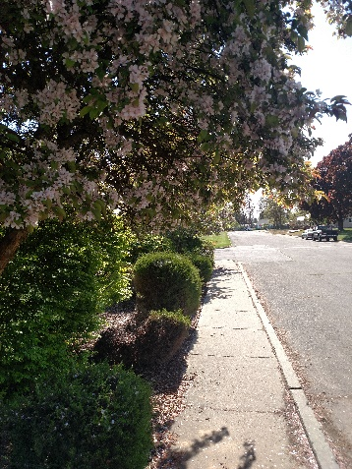

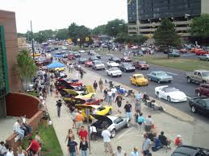

The social impact of automobiles There are some things that you miss out on when hurrying around in an automobile